***Brute Force***

**DVWA**

**Procedure:**

Step 1: Run Docker in root terminal

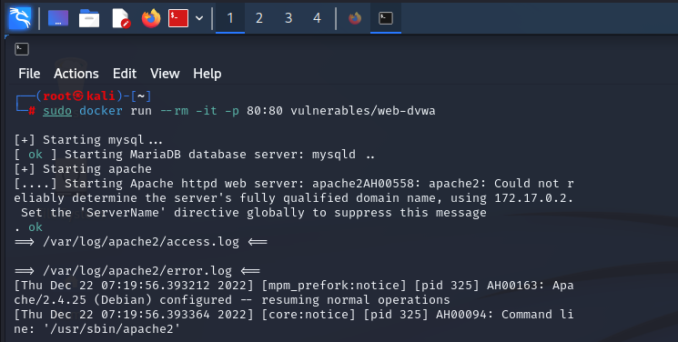

Step 2: connect with localhost on browser and login with username: admin & password: password

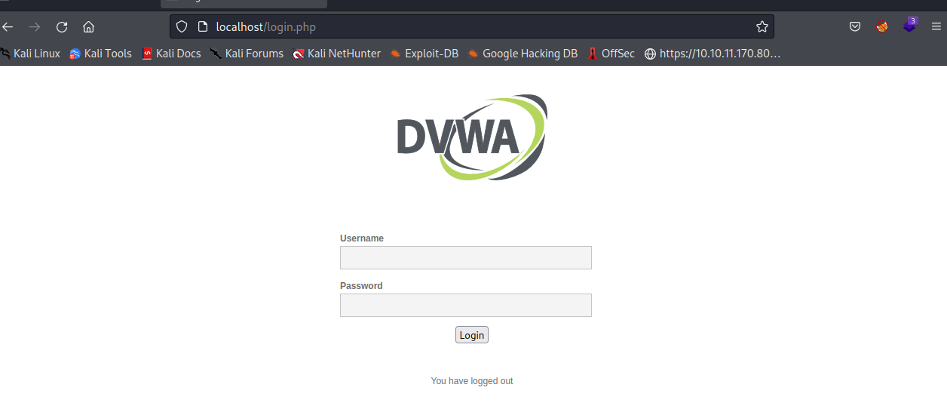

Step 3: select Brute Force and Start find the username and password by using Burp Suite

Step 4: Turn on Foxy proxy

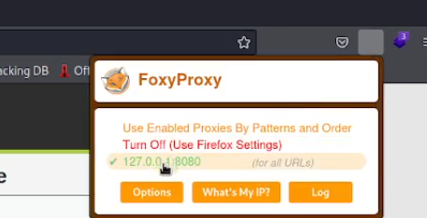

Step 5: open Burp Suite tool then go to proxy turn on intercept mode and capture the request.

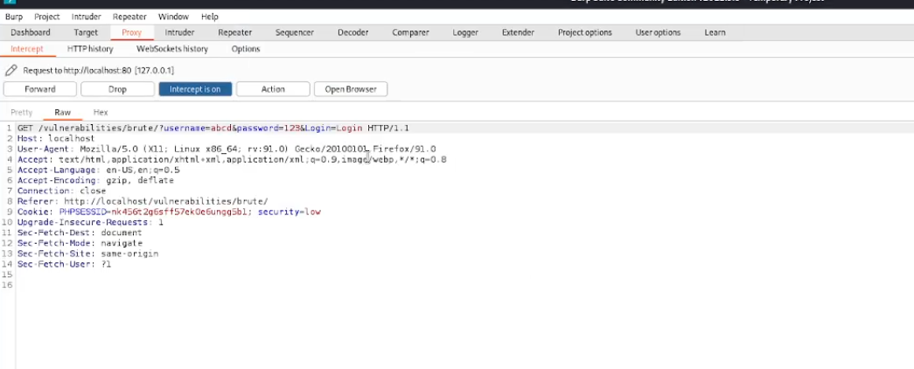

Step 6: click Action to send the to send the request to the intruder

Step 7: select user name & password and change attack type into cluster bomb

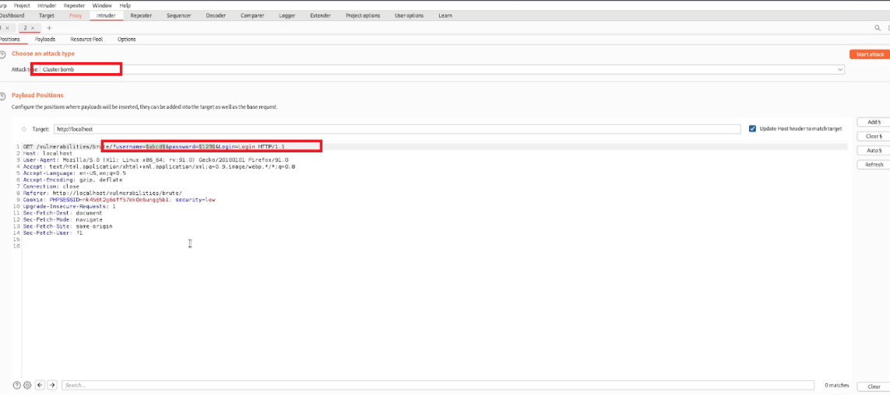

Step 8: Then go to payload and add random related payload for both username and password for Brute Force

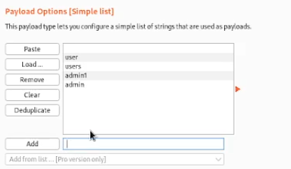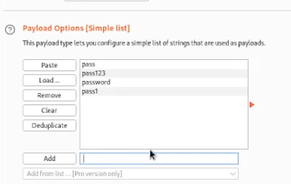

Step 9: click start attack

When the attack is completed, you can get the username & password 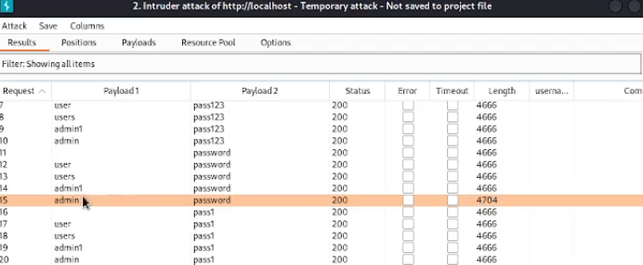

Step 10: To confirm enter the username & password

